Log onto the students Power School account. In this window, look at the left hand column of links and select Pearson Courses.

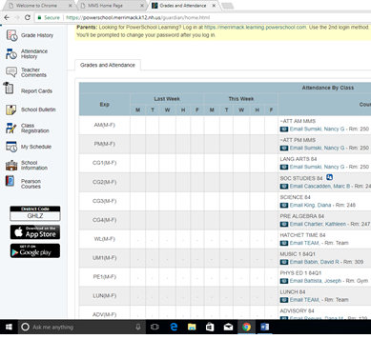

In this window, go to the right hand column and click on the Pearson Realize button.

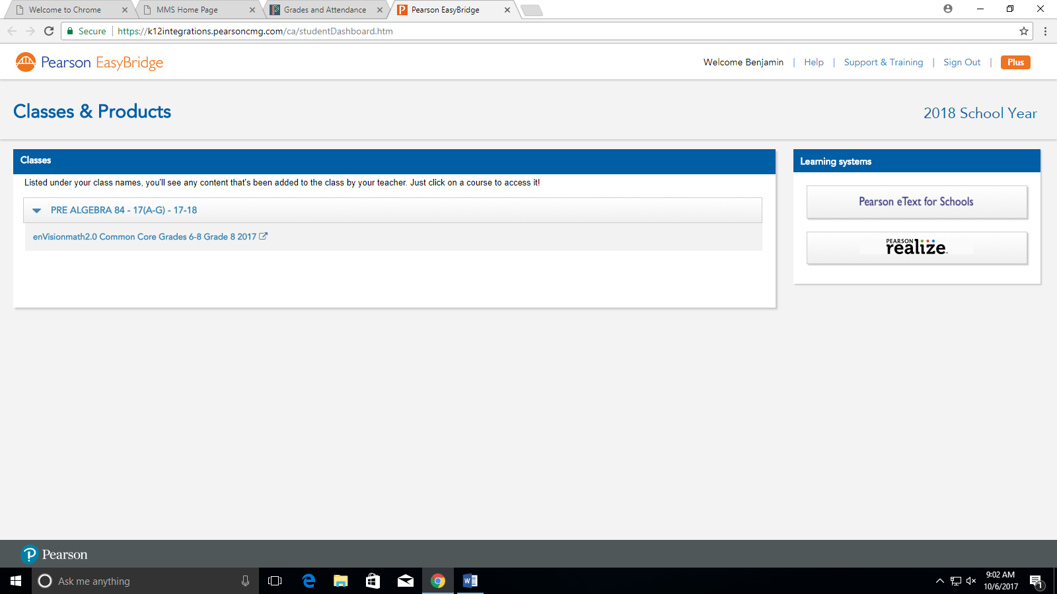

Select the orange rectangle to get to assignments that need to be completed.

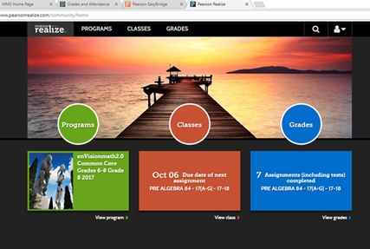

Select the tab Not started and/or In Progress to see assignments that need to completed

